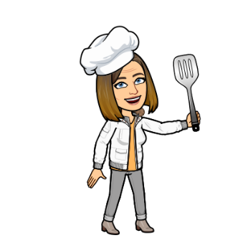
Foods for Teens
Mrs. Amundson
amundsonc@barron.k12.wi.us
Room 163/164
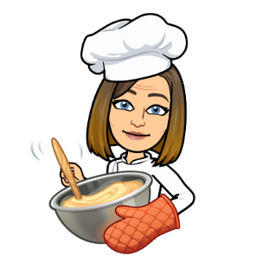
Course Description: Foods for Teens is an introductory course designed for students who have an interest in developing the skills necessary for good food preparation and who wish to improve personal cooking skills. Nutrition is the focal point of this course while demonstrating hands-on experiences. Topics that will be addressed include the purpose of recipes, measuring accurately, following correct safety and sanitation procedures, food preparation skills and the roles of employees in food service today. Some of the topics that will be addressed include: nutrition, myplate, grains/breads, fruits and vegetables, dairy, etc. Cooking with your classmates will be an important part of your learning experience.

Course Goals:
- Students will successfully read and follow basic recipes.
- Students will be able to demonstrate accurate measuring skills.
- Students will demonstrate the ability to work and cooperate with others.

Grading Procedure: Each student will be graded on daily participation, individual projects and daily assignments. Check Infinite Campus weekly. Be prompt about asking me if you have any questions about specific assignments.

Assignments:
- Assignments will be collected and graded. They are due when assigned.
- Participation points will be given on a daily basis.
- Missed labs will need to be made up at home. Complete the lab form found on Google Classroom
- It is YOUR responsibility to check Google Classroom for assignments.
- Each class member is expected to participate in all lab experiences and play an active role in completing the task for the day.

Expectations and Grading:
- Be on time.
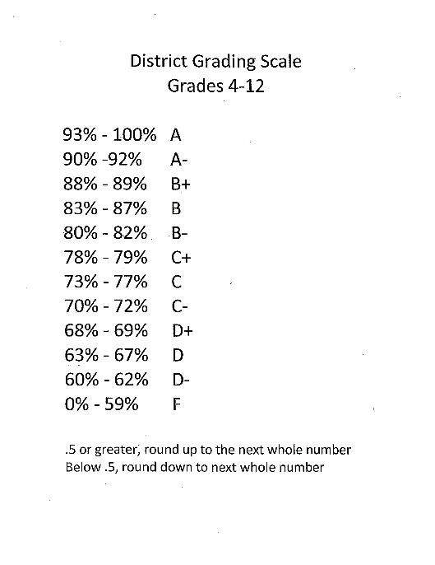
- Be respectful. This means of fellow students and their property, school property and me.
- Always come prepared for class - computer, writing tool, hair tie
- Phones in classroom phone holder
- No outside food or drinks in the classroom.
- Be an active member of your group.
- Have fun!

